**Problem 2:**

2.2 Error Convergence Analysis

The obvious and most important result is, that the local error depends heavily on the step size, which is shown by the rate of algebraic convergence. The results are consistent, since all first order integrator (euler, symplectic euler & backwards euler) have a averaged rate of convergence of around 4 and the second order integrator (Midpoint Method) has a averaged convergence of around 8.

The damping adds no significant effects to the rate of convergence. The deviations in the convergence of the first order integrator (no damping vs damping as well as the difference between the different integrator) is due to the statistical properties of the computed average; a more practical approach could be the calculation of the median instead of the mean.

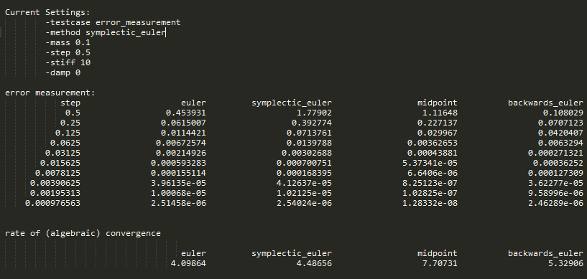

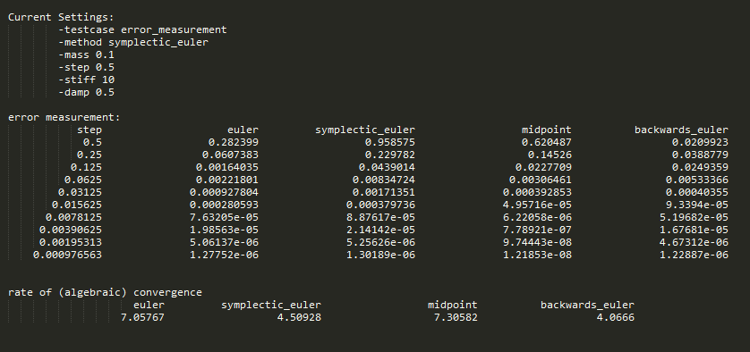

2.3 Stability Analysis

For the both measurements one thing becomes clearly visible. Only one of the applied solver is stable. All the explicit methods which we used become unstable for an increasing step size. The only stable solver is the backwards Euler which is a semi-implicit method and due to its energy preserving properties stability analysis bounded.

The measurements for with and without damping are rather similar. One could argue, that by introducing damping into the system, the rate of instability for the unstable solver slows down, which does make sense due to the nature of damping itself.

